Clinical Pathology of Birds

Kendal Harr, DVM, DACVP

URIKA, LLC

Mukilteo, WA

The goals of this lecture are to discuss basic avian hematology and then clinical chemistry focusing on differences from mammals. It is important to note that the avian RBC uses 7-10 times more oxygen than that of their mammalian counterparts due to increased metabolism which leads to faster cell breakdown and lysis. Therefore, all samples from birds should be processed immediately when possible as at 12 hours, regardless of anticoagulant, lysis will prevent cellular evaluation. EDTA anticoagulated whole blood is generally preferred for hematology, except in ratites and corvids, and heparinized plasma is preferred for clinical chemistry.

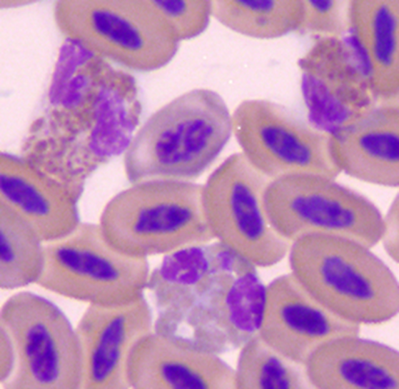Heterophils-e

Heterophils are analogous to mammalian neutrophils. They are first responders in innate infection and will increase in numbers during stress (glucocorticoids), inflammation, and infection. There is variation as the blood values are a steady state number representing a balance between utilization (e.g. in air sacculitis, coelomitis, etc.) and production by the bone marrow. Heterophils are actively phagocytic, large, round cells. Pictured at right are two relatively normal heterophils and an eosinophil from a spotted owlet. The oblong salmon colored granules are typical. Remember that these are in 3D and footballs may appear round when viewed from the side. Toxic changes will appear as dark blue cytoplasm, fewer characteristic cytoplasmic granules, the appearance of purple, primary granules and cytoplasmic vacuolation. Left shifting may occur in response to infection and results morphologically in band-shaped to round nuclei (round=myelocytes). Infectious agents may be found in heterophils or monocytes. Bacteria may be found in avian heterophils, far more frequently than in mammalian blood. This is indication for blood culture and sensitivity.

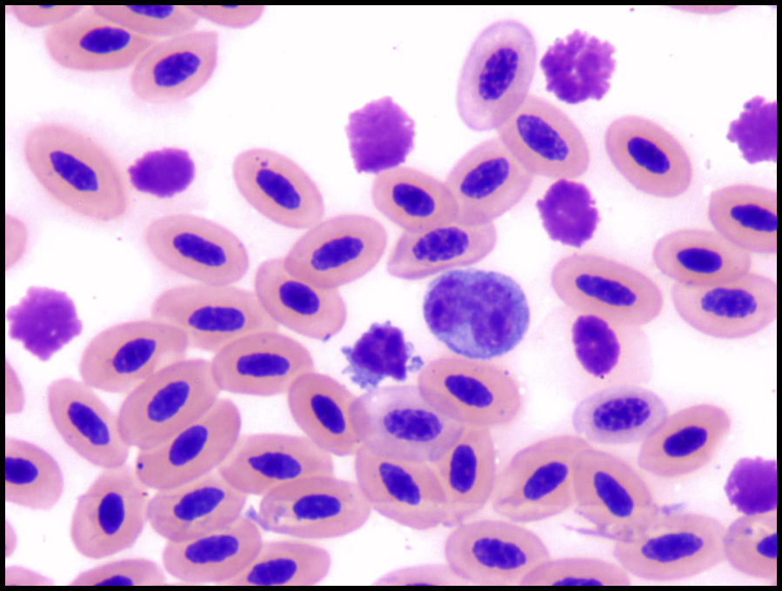Lymphocytes -h

A small well-differentiate lymphocyte is pictured on the left in comparison to a typical monocyte which is approximately the size of an avian RBC.

Mammalian and avian lymphocytes are similar. They vary in size from small to intermediate to large and may be adherent to adjacent cells. The nucleus is typically eccentrically positioned, round to reniform (kidney shaped), and the chromatin may be diffuse to heavily clumped or reticular in appearance. The scant cytoplasm stains blue and may have a pseudopod-like appearance. In diseased animals, lymphocytes become reactive with dark blue cytoplasm which is caused by activated endoplasmic reticulum actively producing proteins such as antibody. Avian species produce antibody that has different structure than mammalian antibody and so many immunoassays are not crossreactive.

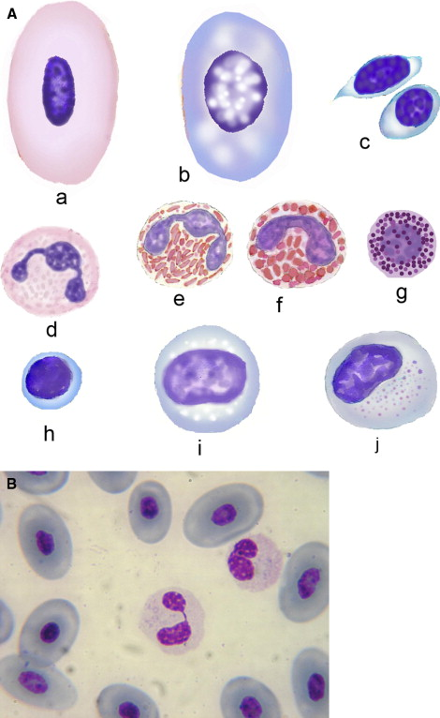Monocytes i,j

The monocyte, the largest leukocyte in birds, resembles the mammalian monocyte. The cytoplasm may contain vacuoles. The ribbon-shaped nuclear chromatin is less clumped than in the lymphocyte. When monocytes become reactive in response to disease, they enlarge in size and develop increased vacuolation. The nucleus becomes rounder with reactivity making differentiation from toxic band neutrophils and highly reactive large lymphocytes difficult. Infectious agents may be found in heterophils or monocytes. Chlamydia-like and pox-like virus intracytoplasmic inclusions may be found in monocytes. Special stains such a Macchiavellis may be required for definitive identification.

Eosinophils -f

Avian eosinophils are generally similar to mammalian cells. The nucleus tends to be minimally segmented and the blue cytoplasm contains large round pink granules in most avian species. Psittacines (parrots, budgies, etc.) have round, bluish granules. Eosinophilic responses are rarely reported in avian species and so are poorly understood.

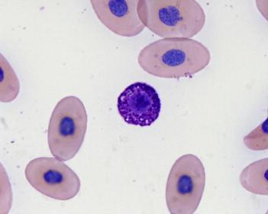Basophils - g

Reptilian and avian basophils resemble mammalian mast cells and their exact origin are still in question. They have round nuclei with clumped chromatin. They have dense basophilic granules which sometimes renders nuclear visualization difficult. Basophilia is uncommon but may be associated with mast cell tumor, allergic, or parasitic response.

Thrombocytes -c

Thrombocytes are platelet analogs but are nucleated like the RBCs. The nucleus is denser, smaller, and rounder than that of the lymphocyte nucleus. The cytoplasm possesses an irregular cell border and the colorless to light blue cytoplasm may be vacuolated. There may be a few large clear vacuoles (glycogen) and small pink granules (alpha granules) used for clotting. Thrombocytes also tend to show aggregation like platelets and especially in heparinized samples are found in clumps. These cells must be differentiated from lymphocytes by the hematology technologist prior to any differential cell counting.

Liver/muscle

Liver disease is common in avian species. Interpretation of standard hepatic analytes used in companion animals must be modified due to physiological differences.

As in large animals, alanine aminotransferase (ALT) is found in hepatic cytosol as well as in muscle and other tissues of birds. Intramuscular injection of doxycycline in pigeons can cause plasma ALT levels to increase above the reference range for greater than 200 hours. This results in a test with poor specificity and does not add any clinically relevant information to an AST value.

Currently, lactate dehydrogenase (LDH) isoenzymes are not measured clinically in non-mammalian species. LDH as a whole is found in most avian tissues and has a low specificity for liver disease. Comparisons of pre- and post-training lactic acid levels in healthy, conditioned and unconditioned raptors’ have been used to establish flight training protocols. LDH has not been used in this regard.

Aspartate aminotransferase is also not specific for hepatocellular damage but returns to normal reference ranges within 100 hours after muscle trauma in pigeons (Lumeij, p.869). It is highly sensitive in detecting liver damage caused by ethylene glycol in pigeons. (Lumeij, p.865) It is currently considered to be a very sensitive indicator of hepatocellular disease in avian species and is frequently used with the muscle specific creatine kinase to differentiate liver and muscle damage. Increases in AST may be caused by hepatocellular damage, muscle damage, VitE/Selenium deficiency, toxins/pesticides, and other.

Most birds produce very little endogenous biliverdin reductase and therefore do not produce bilirubin in health. There are numerous reports, especially in chicken, of jaundiced birds with increased bilirubin. Though generally at trace levels, bilirubin may be useful in diagnosis of hepatic pathology. A potential hypothesis for production of bilirubin is production by bacteria in the intestine and reabsorbed. Biliverdin (the tetrapyrrole – dehydrobilirubin) has been investigated and does not appear to be more useful than bile acids.

Glutamate dehydrogenase (GDH) is found in hepatocyte mitochondria and is considered the most specific indicator of hepatocellular damage. There are also high concentrations in renal tissue; however, most of this is excreted directly into urine and never reaches the blood stream. This enzyme is generally elevated only when there is hepatic necrosis and therefore has low sensitivity. It is important to understand that this may be negative while AST and other enzymes are abnormal with an animal with liver disease. An abnormal GDH is very specific for liver disease and therefore positives are very useful clinically. (Lumeij, p.865)

Gamma glutamyl transferase (GGT) is probably specific to biliary and renal epithelium similar to companion animals. Lumeij found that GGT was increased in the majority of pigeons with experimentally induced liver disease. (Lumeij, p. 868) Marked elevations of GGT in clinical cases of bile duct carcinoma are seen with some frequency as this is the most common hepatic neoplasia in avian species. 0-15 U/L is considered normal at the Schubot Exotic Bird Health Center. This appears to be slightly different in aging Amazon parrots that may have up to 18 U/L without other evidence of liver disease. GGT is most likely elevated in cholestatic conditions and biliary epithelial disorders. Therefore, it will not be sensitive in situations of hepatocellular damage alone. .

Cholesterol metabolism is similar to that of mammals, but there are some specific differences in clinical presentation. In oviparous species, a marked elevation of cholesterol can be seen during vitellogenesis and egg formation. Increases may be seen before the egg(s) can be visualized on radiographs. In general, hypercholesterolemia has an extensive differential list as in mammals and so is not a specific indicator of disease.

There are over 20 different bile acids which can be measured and it is important to remember that this is a category and not a specific compound. The primary bile acids (BA) in humans, dogs, and cats are cholic and chenodeoxycholic acid. In granivorous birds, chenodeoxycholic acid is the predominant bile acid followed by cholyltaurine in chicken and phocaecholyltaurine in ducks. Over 90% of bile salts are reabsorbed in the jejunum and ileum predominantly as glycocholate and taurocholate. In most avian species studied, post-prandial BA levels are higher than preprandial levels. (Lumeij, p.870) There has been one report that in some psittacine species this is variable. The pre and post-prandial sampling performed in companion animals would likely be ideal. However, the crop, an esophageal diverticulum for food storage, has varying emptying times in different species and crop stasis is common in sick birds. Standardization of postprandial sampling is, therefore, difficult. A fasted sample is the preferred sample to eliminate random postprandial elevations. Many birds can be fasted overnight (for 12 hours), however, this should be done with caution in debilitated birds and small species. Raptors can be fasted for 24 hours.

There are two methods of bile acid measurement which can still be found in use today. RIA generally measures nonsulfated conjugated bile acids. There is variability in human test kits caused by the different antibodies binding different amino acid conjugates. Additionally, different bird species have different predominant bile acids than humans. Consequently, different kits will yield different values that may or may not be representative of total bile acids in that species. Further, many kits are linear up to 50 umol/L and so dilutions are frequently needed. The enzymatic method, validated in dogs, cats, and humans, measures the 3 alpha hydroxyl group present in most predominant bile acids. This test will likely best approximate total bile acids present in most avian species. Unfortunately, this spectrophotometric test is markedly affected by hemolysis and lipemia, requiring careful sample handling and quality control. Using the enzymatic method, bile acid values >100 umol/L are considered abnormal and >75 umol/L are suspect. (Lumeij, p.870) Amazon parrots normally have slightly higher bile acid concentrations. Of course, reference ranges for individual species should be generated in each laboratory and validation is necessary.

Bone

Alkaline phosphatase is not present in significant quantities in the liver of any avian species studied. (Lumeij, p.866) It appears to be osteoblast specific and elevations are specific for bony change associated with growth, trauma/repair, osteomyelitis, neoplasia, nutritional secondary hyperparathyroidism, and egg shell deposition.

Glucose

As in mammals, glucose metabolism is modulated by insulin and glucagon. However, healthy birds maintain blood glucose minimally >150 mg/dl, with levels up to 800 mg/dl in hummingbirds.

There are species differences in the way glucose is regulated. The insulin content of the pancreas of granivorous species is about 1/6 that of mammalian counterparts, while the glucagon content is about two to five times greater. Pancreatectomy induces hypoglycemic crisis in granivorous birds but produces diabetes mellitus in carnivorous birds. (Lumeij, p.876) This suggests that glucagon may predominate in granivorous birds while insulin may predominate in carnivorous birds. Though diabetes is generally attributed to increased glucagon in psittacines, there have been reports of documented decreased blood insulin in comparison to a normal bird and positive response to insulin therapy. A Type 1 diabetes-like case in a Macaw has been confirmed at necropsy (Pilny, 2005) and a case of pancreatic hypoplasia in and Eclectus parrot was confirmed at necropsy. It is, therefore, possible that either glucagonemia or hypoinsulinemia are responsible for diabetes in psittacines and other species. Each individual should be thoroughly evaluated to establish appropriate therapy.

Hyperglycemia is induced in birds by elevated levels of either endogenous or injections of glucocorticoids. Although a positive urine glucose is an indicator of hyperglycemia, stress hyperglycemia may cause a 3+ response on a urine dipstick. Since avian urine/urates are retropulsed into the colorectum, false positive glucose and protein may occur, especially in frugivorous birds. Positive ketones on the urinary dipstick is less common and this is likely diagnostic for diabetes mellitus. However, migratory birds are regularly ketotic due to extensive exercise and so previous activity must also be considered. A bird’s clinical chemistry, urinalysis, and clinical signs should all be considered prior to diagnosis of diabetes mellitus. Potential measurement of insulin and glucagon may be considered by no hormonal assay have been validated according to ASVCP guidelines in birds. These may be compared to concurrently analyzed normal animals with the knowledge that there may a complete lack of crossreactivity in the assay. Garbage numbers may result.

Many granivorous species of birds will become hypoglycemic due to malnourishment. The smaller species may become hypoglycemic after a 12 hour fast especially if debilitated. Carnivorous birds can generally maintain plasma blood glucose levels much longer than granivorous species. Hypoglycemic seizures have been reported in raptors below 80 mg/dl. These low levels are generally due to flight training after restricted food intake.

As would be expected, maldigestion and malabsorption is also a possibility in birds though less commonly diagnosed. In addition to clinical examination of feces, a carbohydrate absorption test can be performed in most species in a similar manner to mammals (horses).

Electrolytes

There has been extensive study on intestinal absorption of electrolytes and calcium transport in chicken. One may access the literature through Whittow. The predominant anions and cations are similar to mammals. Reference values in the literature should be critically evaluated since many are based on studies performed prior to the existence of ISE electrodes.

Hypernatremia and hyperchloremia in combination are most consistent with dehydration which is commonly observed.

As in mammals, hypochloremia is typically associated with gastrointestingal disease including decreased reabsorption in the upper intestine or potential obstruction.

Protein

Reference ranges for birds are significantly lower than those for mammalian species. The total protein value generated using a refractometer is frequently inaccurate due to high concentrations of other refractile compounds in plasma, such as chromagens, lipids (egg laying), and glucose. (Recall that a hummingbird normally has a blood glucose of 800 mg/dl.) The biuret method, found on wet chemical analyzers, is the most accurate method to quantify total protein. (Lumeij, p.860)

Plasma gel electrophoresis is the gold standard used to determine albumin and evaluate globulin distribution. It is also a useful aid for monitoring therapeutic response in animals that frequently show few overt clinical signs. Plasma proteins identified in the classic banding pattern of avian species include transthyretin in the prealbumin fraction; albumin; alpha1 –anti trypsin in the alpha1 zone; alpha2-macroglobulin and haptoglobin in the alpha2 zone; fibrinogen, beta-lipoprotein, transferrin, complement, and vitellogenin in the beta zone; immunoglobulin and complement degradation products in the gamma zone. Transthyretin has replaced “prealbumin” in human medical vocabulary. This protein binds thyroid hormones and retinol with varying affinities for the different hormones across mammalian, avian, and reptilian species. It has greater than 98% homology and has been shown to have a very similar banding pattern across species. (Chang et al., 1999, Farer et al, 1962)

The bromcresol green (BCG) methodology is a nonspecific protein binder and is not validated in birds, but in dogs. Significant discrepancies have been shown between BCG and gel electrophoresis. This disparity is caused, in part, by the use of a human albumin standard and control which has a different binding affinity for the dye than does avian albumin. Gel electrophoresis is the recommended method of albumin determination in avian species. Reference ranges for species of birds should be established in each laboratory.

Albumin:globulin (A:G) ratio can be decreased in disease states such as inflammation, protein losing nephropathy, and liver failure. However, females of oviparous species can also have a physiological decrease in A:G ratio. The majority of the yolk proteins and chalazae band in the globulin region. Albumin is only very mildly increased during egg formation. This results in a decreased A:G ratio that does not indicate a diseased state.

References

Campbell, T. and Ellis, C. 2007. Avian and Exotic Animal Hematology and Cytology, Third Edition.

Harr, KE. 2002. Clinical chemistry of companion avian species: a review. Vet Clin Pathol 31:140-151.

Hawkey, C.M. and Dennett, T.B. 1989. Color Atlas Of Comparative Veterinary Hematology.

Lumeij, JT. 1997. Avian Clinical Biochemistry. in Clinical Biochemistry of Domestic Animals. Kaneko, Harvey, and Bruss (ed). Academic Press, Harcourt. San Diego. p 857-877

Pilny, AA and Luoung R. 2005. Diabetes Mellitius in a Chestnut-fronted Macaw (Ara severa). Journal of Avian Medicine and Surgery. 19(4):297-302.

Whittow, G. C. (ed). 2000. Sturkie’s Avian Physiology – 5th ed. Academic Press, Harcourt. San Diego.