Clinical Pathology of Reptiles

Kendal Harr, DVM, DACVP

URIKA, LLC

Mukilteo, WA

Temperature

Reptiles are ectotherms and can survive a range of body temperatures that would kill domestic mammals. Active reptiles will behaviorally thermoregulate to maintain their core body temperature within 15 to 20ºF (8-11ºC), for instance - between 70-85ºF (21-32ºC). However, they can survive physiological core body temperature ranges of 30 to 40ºF (17-22ºC) or more in states of torpor or hibernation. Diseased animals may become severely chilled or overheated which may result in the animal’s death.

Blood gases

Changes in blood temperature of this magnitude will cause marked changes in pH as well as the concentrations of other ionized electrolytes. The preprogrammed computerized calculations based on Sigaard-Anderson nomograms made by the I-STAT and other pH, oxygen, and electrolyte monitors are not accurate if the body temperature is significantly different from 98.6ºF or 37ºC. Electrolye values can be changed significantly as pH changes and so these may or may not accurately represent that found in these species. This should be considered when clinically assessing an animal or analyzing data from research or clinical studies.

Enzymes

For all species, enzyme activity is measured by analyzers, not the actual enzyme concentration. So, a substrate concentration is first measured. Plasma is then added, enzymatic reaction takes place within the cuvette, and then a second substrate measurement is taken. From this activity, measured in IU, is calculated. This reaction is based on kinetics specific to the enzyme being investigated. Enzyme kinetics is directly affected by temperature and the enzyme kinetics curve will vary significantly if temperature is changed. Therefore, in diagnostic medical analyzers, temperature is strictly regulated at 37ºC. Obviously, this is not the typical core temperature of most reptiles. What the real enzyme activity is in the reptile’s body remains a mystery even after biochemical evaluation. Liver enzyme increases are reported in disease but changes may also be found to be minimally associated with disease likely due to inaccurate measurement of activity.

Glucose

Reptiles metabolize at a much slower rate than mammals and birds and therefore do not require the same level of glucose. Typically glucose measurements are lower in reptiles than in mammals and bird with a general range of 60-99mg/dl. Changes in the animal’s body temperature may change measured glucose. Severe temperature changes result in stress and hyperglycemia. Reports vary and either hyperglycemia or hypoglycemia due to temperature change can occur. In general, in the summer months when the temperature is higher and metabolism is faster, higher blood glucose values within the normal range are expected, typically not over 100mg/dl. In the winter, when the animal is colder and potentially in torpor, blood glucose is lower and the animal may appear hypoglycemic. Physiological stress has been reported to cause hyperglycemia in crocodiles and snakes and injection of hydrocortisone induces hyperglycemia in several species of reptiles. This will rebound with warming. Insulin and glucagon have similar effects in reptiles upon injection as they do in mammals.[Dessauer, 1970]

Calcium/electrolytes

Turtles tend to have lower potassium and higher bicarbonate reference values.

Avian and reptilian total calcium values can be far higher in normal physiological circumstances than would be tolerated by a mammal. Dramatic elevations are seen in reproductive, oviparous females. Reproductively active, healthy female iguanas may have total calcium values exceeding 40 mg/dl. (Harr et al., 2001) Certain species, such as the indigo snake, have markedly high plasma total calcium levels in both male and females. Reproductive pathologies such as egg binding and egg yolk peritonitis can also result in marked hypercalcemia. Marked hypocalcemia can be caused by malnutrition or reproductive pathology such as chronic egg laying.

Ionized calcium levels are temperature and pH dependent. When temperature is controlled to 80-85ºF (27-30ºC), ionized calcium concentrations in iguanas falls within a very small reference range of 1.27-1.67 mmol/L. (Dennis et al., 2001) Ionized calcium levels are used to assess functional calcium status in animals with external evidence of disease (e.g. muscle tremors) at the University of Florida.

In iguanas, the calcium/phosphorus ratio is used to differentiate physiologic reproductive hypercalcemia from renal pathology. Normal female iguanas may have markedly elevated calcium and phosphorous concentration but all will have a Ca:P ratio greater than one. If the Ca:P ratio is less than one, renal disease and nutritional secondary hyperparathyroidism should be considered. The calcium x phosphorus product, used in mammals to evaluate renal function and potential mineralization, can be dramatically elevated (up to 800) in normal gravid female iguanas. (Harr et al., 2001)

Hematology

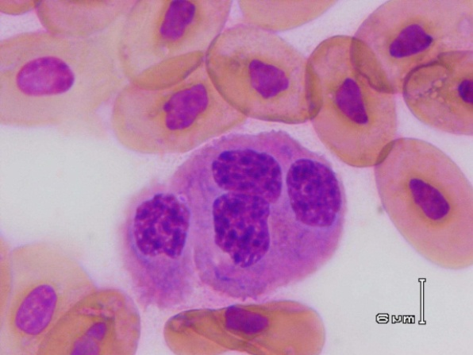Azurophils

Azurophils are unique to snakes. They resemble monocytes, but have a distinct eosinophilic staining to the cytoplasm with Romanowsky stains. The cytoplasm shows a tendency to vacuolation. It is postulated that they are derived from monocytes. Cytochemically these are strongly peroxidase positive and an intermediary between the heterophil and monocyte, an evolutionary bridge. An association with bacterial infections and azurophilia does exist.

While cells similar to azurophils may be found in other reptile species, when examined with cytochemical stains these cells have been found to be of similar staining and therefore functions to monocytes. Therefore, in other species, these can be counted in the monocyte category.

Heterophils

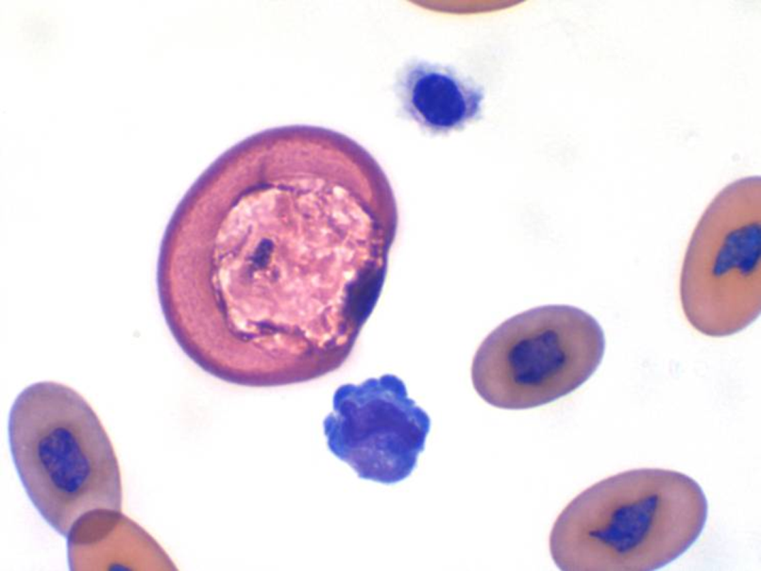Heterophils are analogous to mammalian neutrophils. They are first responders in innate infection and will increased during stress (glucocorticoids), inflammation, and infection. Heterophils are actively phagocytic, large, round cells. Snakes have the largest heterophils of the reptiles. The nucleus in many reptilian heterophils is non-lobed and round but is similar to band mammalian neutrophil is some common species such as the green iguana, chameleons and geckos (rhyncocephalid saurian). The cytoplasm contains elongated eosinophilic or salmon colored granules. In chelonia and crocodilia, the granules are more spindle shaped. Snakes have large, pleomorphic granules. Squamate heterophils may appear very refractile and blob-like when there is heparin artefact as pictured at right. With inflammatory disease in reptiles, the morphological abnormalities are generally more significant than a heterophilia. Toxic changes will appear as blue cytoplasm, a non-lobed nucleus in those species with lobed nuclei, fewer characteristic cytoplasmic granules, the appearance of purple, primary granules and cytoplasmic vacuolation. Infectious agents may be found in heterophils or monocytes. Bacteria are typically found in heterophils.

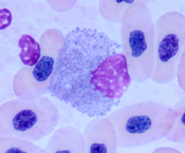

Eosinophils -f

Avian eosinophils are generally similar to mammalian cells. The nucleus tends to be non-lobed and the cytoplasm is blue. Iguanas have round, bluish granules. Chelonia and crocodilia have round-to-oval granules. True eosinophils have not been identified in snakes and some lizards. A true eosinophilic response is not recognized for most reptiles.

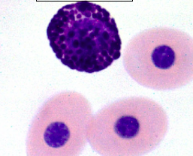Basophils - g

Reptile and avian basophils resemble mammalian mast cells and their exact origin are still in question. They have round nuclei with clumped chromatin. They have dense basophilic granules which sometimes renders nuclear visualization difficult. Basophils are numerous in blood of terrapins and most aquatic species such as alligators normally which is quite different than the rarity one expects in mammalian species. Additionally, these species appear to increase basophil numbers with bacterial infection and so their role may not be the typical mammalian allergic/parasite response that we might expect.

Erythrocyte response in disease

Normal Erythrocyte Morphology and Function

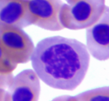Unlike mammalian erythrocytes, reptilian, avian, amphibian and piscine red blood cells (RBC) have nuclei. Nucleated RBCs are elliptical and larger than non-nucleated RBCs with amphibian RBCs being the largest. In general, mature reptilian erythrocytes have nuclei that are irregularly round to oval, with dense pyknotic chromatin and homogenous eosinophilic (red) cytoplasm. Reticulocytes, immature erythrocytes, have a similar shape but are slightly rounder with light blue cytoplasm upon Romanowsky staining. Reticulocyte nuclei contain clumped chromatin with obvious, pale euchromatin indicative of the active hemoglobin production occurring in these cells. Rubricytes, immature reticulocytes, have round, slightly irregular nuclei with clumped chromatin and round, dark blue cytoplasm. This cell type should not be confused with small lymphocytes. This stage of erythrocyte may be present in the blood stream and is capable of replication. Therefore, mitotic activity may be seen in the erythrocyte line in blood smears, and especially in samples with active regeneration. Mitotic activity in reptilian peripheral blood is not indicative of a neoplastic process.

Erythrocyte size, number and hemoglobin content have been compared between 441 species of mammals, birds, and reptiles. Reptiles have lower total number RBC, mean cell volume (MCV), hemoglobin concentration, and PCV than either mammals or birds. These findings indicate that the oxygen-carrying capacity of the blood is highly conserved in birds and mammals but is lower in exothermic animals such as reptiles.

Erythrocyte function is similar to that of mammals though adaptations exist across this diverse class of animals. Nucleated RBCs contain hemoglobin tetramers that carry oxygen and carbon dioxide to and from the tissues respectively. Hemoglobin structure appears to be relatively well conserved across the species of the class Reptilia. However, small changes in molecular structure result in significant variation in oxygen affinity. In general, lizards tend to have a significantly higher oxygen affinity while chelonia have decreased oxygen affinity. Two functionally different hemoglobin tetramers have been separated from the blood of adult red-eared freshwater turtles (Trachemys scripta) which exhibit marked differences in oxygen affinity and in concentration of ATP associated with the hemoglobin. It is postulated that these two hemoglobin molecules exist in the same RBC though this functional difference may be due to erythrocyte age as it is in mammals. Additionally, turtle erythrocytes have been proposed as a model for the evolutionary transition state between RBCs relying on aerobic metabolism and the anaerobically metabolizing mammalian RBCs, a transition that is homologous to that occurring in maturing mammalian RBCs.

Red blood cells are continuously produced by bone marrow elements and removed from the blood by phagocytes present in splenic tissue. Production of erythrocytes occurs predominantly in the extravascular space in bone marrow though erythroid precursors can also replicate in the peripheral blood. In neonates, the yolk-sac is the primary site of erythropoiesis which may continue through the first year of life. The lifespan of mammalian red blood cells is proportional to size and ranges from 2 to 5 months in domestic animals. Nucleated red cells have an increased life span in comparison to mammalian red cells. For instance, turtle erythrocytes may live for up to 11 months. Nucleated red blood cells undergo programmed cell death and offer an excellent model for the study of apoptosis. Investigation in this area is just beginning.

Gender differences have been reported in several species of reptiles but this appears to vary with species and potentially with the study. Male New Guinea snapping turtles (Elseya novaeguinae) and grass snakes (Natrix natrix) have been reported to have significantly higher hemoglobin, PCV and bilirubin (a hemoglobin breakdown product) than females. While non-gravid and gravid female green iguanas were reported to have significantly higher hemoglobin concentrations, PCV, and MCHC than males.

Though methemoglobin has been reported to be significantly increased and present in concentrations in healthy reptiles that are only considered pathologic in mammals, recent studies are changing this concept. More recent studies, in which techniques to prevent the oxidation of methemoglobin are instituted in study design, reveal that methemoglobin values are actually similar to mammalian values. Older literature reports apparently healthy snakes with methemoglobin percentage ranging from 6-28%, lizards with methemoglobin ranges of 2-5%, and turtles with methemoglobin percentages of a massive 5-60% in healthy animals This is in direct contrast to studies designed to compare methemoglobin across species where no statistically significant difference could be found between mammals, reptiles, and birds using the same methodology. Additionally, more recent studies in Elapid snakes (Pseudechis phorphyriacus) revealed a lower methemoglobin of 3% which is more consistent with mammalian values, less than 2% methemoglobin was present in Crocodylus porosus, C. johnstoni, Chelodina longicollis, and Sphenomorphus quoyi, and less than 1% methemoglobin present in Geochelone denticulata and G. carbonaria. This indicates that high methemoglobin concentrations and methodologies prior to 1975 are circumspect and values should be rechecked with contemporary experimentation prior to further quotation in the literature.

Abnormalities

Characterization of disease processes associated with abnormal erythrocyte morphology has been limited in reptiles. Polychromasia (multiple colors) is the presence of bluish or immature RBCs on stained blood smears. It is observed with some frequency in moderately to severely anemic reptiles. This represents a regenerative response and an attempt by the animal to return to homeostasis. Low numbers (<1% RBC number) of reticulocytes may be present in normal blood smears and generally are not reported as polychromasia.

Reptilian erythroid regenerative response appears to be slower than that observed in mammals. When anemia was induced in turtles (Pseudemys elegans) with phenylhydrazine hydrochloride, 30 days elapsed prior to any regenerative response and the authors report up to eight weeks prior to maximal regenerative response. Rabbits showed a regenerative response in 5 days in the same study. Decreased mean corpuscular hemoglobin concentration (MCHC) and decreased mean cell volume (MCV) have been documented to be associated with reticulocytosis and polychromasia in reptiles. Both mammalian and reptilian reticulocytes contain decreased quantities of hemoglobin which is actively produced in these immature cells, resulting in decreased MCHC. In mammals, MCV generally increases during a regenerative response due to the slightly larger size of mammalian reticulocytes. However, reptilian reticulocytes are generally smaller in size than mature reptilian RBCs, resulting in decreased MCV.

Intraerythrocytic inclusions

Normal intracytoplasmic inclusions may be seen in several chelonians. These single, small, blue, punctate inclusions may be present in a few erythrocytes or a majority of erythrocytes in a blood smear with no known clinical significance. Ultrastructural investigation reveal that these inclusions are consistent with degenerate organelles.

Similar intracytoplasmic inclusions in American alligators (Alligator mississipiensis) are only seen in animals with significant infection. Generally, these red cell inclusions are concurrently observed with toxic change in the heterophil cell line. Numerous round to oval intracytoplasmic inclusions are found in mature and immature erythrocytes in peripheral blood smears and in immature erythrocytes in bone marrow impression smears. The inclusions stained clear to lightly basophilic on Wright's stain, lightly basophilic on Wright-Giemsa stain, periodic acid-Schiff (PAS) positive, and Sudan black B negative. Upon ultrastructural examination, some of the vacuoles contained degenerate organelles and ferritin aggregates. Leading to the hypothesis that they may be autophagosomal and formed during the maturation process of the erythrocyte.

Square to rectangular to occasionally hexagonal, pale, crystalline-like cytoplasmic inclusions consistent with hemoglobin crystals were in initially investigated in Rhinoceros iguanas (C. cornuta and C. figgensi) using transmission electron microscopy. In the authors experience, similar crystals are observed with some frequency in various species of lizards, snakes, and tortoises. These have been documented in the literature in the green iguana (Iguana iguana), and crystals may also be observed in the nucleus in this species. The cause and significance of these inclusions are unknown. However, ultrastructural analysis of the hemoglobin protein reveals microtubules of polymerized hemoglobin which are virtually identical to those observed ultrastructurally in RBCs of deer and humans with sickle cell anemia. These proteins are found in low percentages in normal animals (<1%) and diseased rhinoceros iguanas (5-10%). It is unlikely that these low numbers of afflicted RBCs significantly impact oxygen transport. It should be noted that these crystals can be found in healthy, reproductively active animals and so the clinical significance is unknown. Genetic influence should be investigated, especially in a captive breeding situation.

Viral inclusions have been observed in erythrocyte cytoplasm. A fer de lance (Bothrops moojeni) snake, that was being evaluated for renal carcinoma, was found to have two types of inclusions present concomitantly in the same RBC. One type of inclusion contained viral particles and the other inclusion was crystalline and contained an unknown protein. The snake was markedly anemic and exhibited a marked regenerative response. Ultrastructural analysis revealed an iridovirus consistent with snake erythrocyte virus and the crystalline structures that were different than typical hemoglobin crystals. The viral inclusions are similar to acidophilic (blue) inclusions in east African Chameleons (Chamaeleo dilepis) documented on electron microscopy to contain viral particles consistent with the family Iridoviridae. Erythroparasites are also present in RBC cytoplasm and may be confused with true inclusions. Some parasites may be associated with anemia and other pathologic disease states.

Anemia and polycythemia

Artifactual changes should be ruled out prior to interpretation of anemia in reptiles. Lymphatic vessels are present in close proximity to blood vessels in the tail, forelimb, and other regions of the body. Dilution of the blood sample with lymph results in decreased PCV, hemoglobin concentration, etc. If the sample has a decreased PCV with no evidence of regeneration and increased numbers of small lymphocytes, submission of a new sample should be requested to verify results. Clinical chemistry values will vary dependant on which organ or disease process the lymph is draining, however reports in reptiles reveal a decreased protein as well as decreased potassium in lymph fluid.

Upon confirmation that the sample is representative of the patient, anemia should be characterized and the following potential diagnoses should be ruled out. Anemia may be caused by increased RBC destruction, decreased RBC production, or blood loss. The anemia should be characterized based on polychromasia and reticulocyte count as either regenerative or nonregenerative. It should be noted that reptiles have increased time to regenerative response so one must consider the chronicity of the anemia. In general, if the anemia has persisted for more than one month with no significant response it may be classified as nonregenerative. Many systemic inflammatory diseases as well as liver and renal failure may result in nonregenerative anemia.

Viral infection has been documented to cause moderate to severe anemia. A decrease in mean PCV of approximately 35% was observed in green sea turtles afflicted with severe fibropapillomatosis (herpes) when compared to a population of normal animals. This disease is also associated with decreased total protein, white blood cells including lymphocytes, basophils, and eosinophils. No mention of thrombocyte changes caused by herpes could be found in the literature. However, this is likely a result of study design and requires further investigation. The fact that multiple cell lines are decreased in herpetic infection indicates that there is likely a change in bone marrow microenvironment causing a component of decreased cell production in this disease. Further investigation is warranted.

Evidence exists that toxin exposure may cause anemia. Concentrations of Sigma chlordanes in fat biopsies from Laggerhead sea turtles were negatively correlated with red blood cell counts, hemoglobin, and hematocrit.

Starvation results in decreased RBC number, PCV, and hemoglobin concentration in snakes. Additionally, when exposed to human hormones, red cell mass in these starved snakes (Xenochrophis piscator) can be increased by hormone combinations including urinary erythropoietin and L-thyroxine. It appears that these hormones work synergistically to stimulate erythrocyte production. There may also be a circadian effect on erythrocyte production where exposure to sunlight is a positive synergistic factor.

During hibernation and dry periods reptiles may not drink for weeks to months at a time. This results in a dehydrated state and potentially marked changes in blood values that should not be overly interpreted. Both hemoglobin and PCV have been documented to increase due to these seasonal and annual changes in Desert tortoises However, statistically significant (p<0.01) decreased PCV and hemoglobin concentration have been documented in a laboratory setting in the lizard, Egernia cunninghami when exposed to low temperatures. In this study, a decrease of 12˚C over a 48 hour period resulted in a decrease of >20% in PCV and hemoglobin concentration when compared to control lizards housed at optimal temperatures. Additionally, chronic cold and submergence has been explored in the hybernating turtle, Chrysemys picta. When housed at cold temperatures equivalent to winter, hemoglobin in this species exhibited a significant right shift and increased oxygen affinity even with concurrent decrease in pH. These observed changes in blood oxygen transport may facilitate oxygen loading during winter submergence thereby allowing hibernation underwater. In conclusion, knowledge of the individual species and exact environmental stressors is required for interpretation of blood changes in hibernating reptiles.

References

Dessauer, H. 1970. Blood Chemistry of Reptiles: Physiological and Evolutionary Aspects. in Biology of Reptilia – Vol 3. Gans (ed). Academic Press, New York. p. 1-54

Strik, NL. Alleman, AR, and Harr, KE. 2007. Chapter 3 Circulating Inflammatory Cells In: Infectious Diseases and Pathology of Reptiles. CRC Press:Boca Raton.