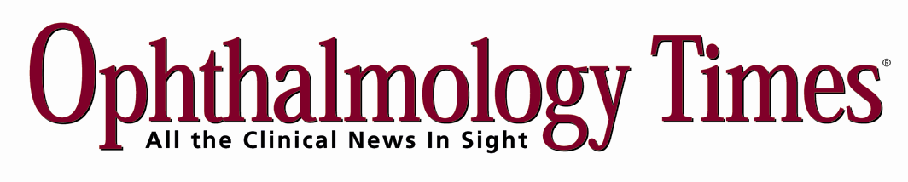

Dear Valued *Ophthalmology Times* Reader:

Over the years, the ***Ophthalmology Times* Best Programs Survey** has become a highly regarded survey among ophthalmologists, researchers, and residents (even, residents-to-be). Each year, we continue to improve upon its credibility.  
  
This year, *Ophthalmology Times* is expanding the survey to include ophthalmologists on its E-mail circulation list. In addition, the survey also will include the chairmen and resident advisors of the major ophthalmic institutions across the country, as in the past.

I am writing to ask for your participation in the **15th Annual *Ophthalmology Times* Best Programs Survey**.  
  
Please take a moment to vote and submit your responses. **Deadline is Wednesday, September 1st.** Your responses will remain strictly confidential and will be used for statistical analyses only. The survey is attached and should take less than 5 minutes to complete.

Please vote for the top 10 programs in each of these four categories:

1) Best Overall  
 2) Best Patient (Clinical) Care  
 3) Best Research  
 4) Best Residency

The Top 30 ophthalmic programs are listed, with options for write-ins. Indicate which schools should be ranked—with 1 being the top program and 10 being the 10th-best program. If there is an ophthalmic program you feel deserves recognition but is not listed, please fill in the name of the program in one of the “other program not listed” slots and include the number of the ranking.

For taking part in this year’s Best Programs Survey, your name will be submitted in a **drawing for one of 2 Apple iPads**. The results of the Best Programs Survey will be published in the October 1st issue of *Ophthalmology Times*.

Many thanks in advance for your time and input. If you have any questions, please free to contact me at mdlugoss@advanstar.com.  
  
Best regards,  
  
Mark L. Dlugoss  
Editor-in-Chief