Subject Line: Need better efficiencies and improved outcomes for process development?

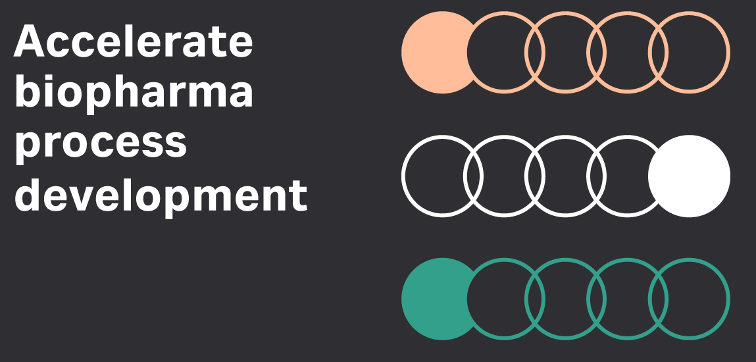

The biopharmaceutical industry is moving at much faster speeds today and working with more diverse and complex molecules. Understanding how to navigate this evolving landscape and improve your efficiency is key. Learn more about the tools and process you can use to move your process forward.

**Understanding and controlling raw material variation in cell culture media**

Manage variability through advanced analytical methods and risk-based assessment.

<https://www.cytivalifesciences.com/en/us/solutions/bioprocessing/knowledge-center/Cell-culture-material-variability>?extcmp=CY20015-GL-BP-PD-AcceleratePD2020Upstream-BioPharmeblast

**Optimizing process efficiency in upstream manufacturing**

Process efficiency is a key goal for biopharmaceutical production, focused on increasing the process' speed, keeping costs under control, and building flexibility into the process, all while maintaining the quality of the final product.

<https://www.cytivalifesciences.com/en/us/news-center/optimizing-process-efficiency-in-upstream-manufacturing-10001#:~:text=Process%20efficiency%20is%20a%20key,%2C%20and%20cost%2Deffective%20process>?extcmp=CY20015-GL-BP-PD-AcceleratePD2020Upstream-BioPharmeblast

**Cell Culture Titer & Protein Quality**

Using the right medium can help you increase quantity, quality or both.

<https://www.cytivalifesciences.com/en/us/solutions/bioprocessing/knowledge-center/titer-and-protein-quality>?extcmp=CY20015-GL-BP-PD-AcceleratePD2020Upstream-BioPharmeblast

**Simplifying cell culture expansion**

Controlled perfusion in a closed, single-use bioreactor can cut the complexity from your cell culture expansion process, making it possible to go from seed train to full production in a single, cost-effective step.

<https://www.cytivalifesciences.com/en/us/solutions/bioprocessing/knowledge-center/concentrated-fed-batch>?extcmp=CY20015-GL-BP-PD-AcceleratePD2020Upstream-BioPharmeblast