**To:** (exclude anyone with Academia email)  
  
**Subject line A**: Get compliance-ready with our new CCD imager  
**Preview pane:** Robust lab imager with data traceability

**Subject line B**: Robust lab imager with data traceability  
**Preview pane:** Get compliance-ready with our new CCD imager

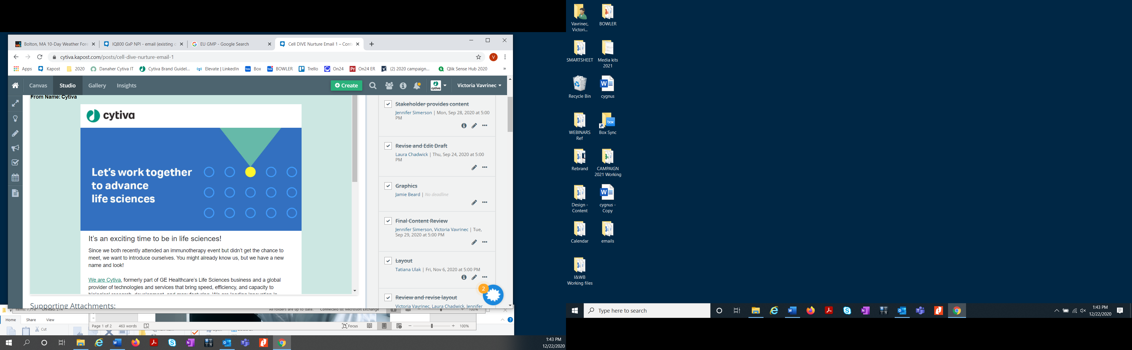

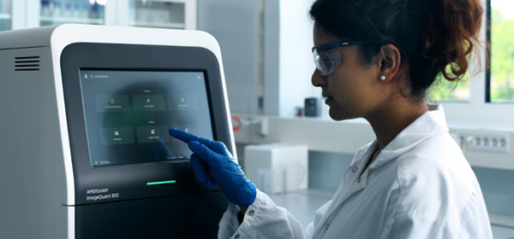

**~~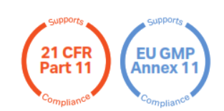~~**  
Hello [First name],

We’re writing to let you know about our new gel and blot imaging system with GxP software capabilities. The [ImageQuant 800 GxP](https://cdn.cytivalifesciences.com/dmm3bwsv3/assetstream.aspx?mediaformatid=10061&destinationid=10016&assetid=45098?extcmp=cy21009-gl-gcr-gen-iq800gxpnpi-em-exv-biopharm-npi) imaging system combines with [ImageQuant TL GxP analysis software](https://www.cytivalifesciences.com/shop/molecular-biology/nucleic-acid-electrophoresis--blotting--and-detection/molecular-imaging-for-nucleic-acids/imagequant-tl-10-0-analysis-software-p-25516?extcmp=cy21009-gl-gcr-gen-iq800gxpnpi-em-exv-biopharm-npi) to support your compliance with 21 CFR Part 11 and EU GMP Annex 11 frameworks.

It’s designed specifically for regulated environments like yours where data traceability, integrity, and accountability are critical. Plus, you get top-quality gel and blot images, along with full control of your data through automation.

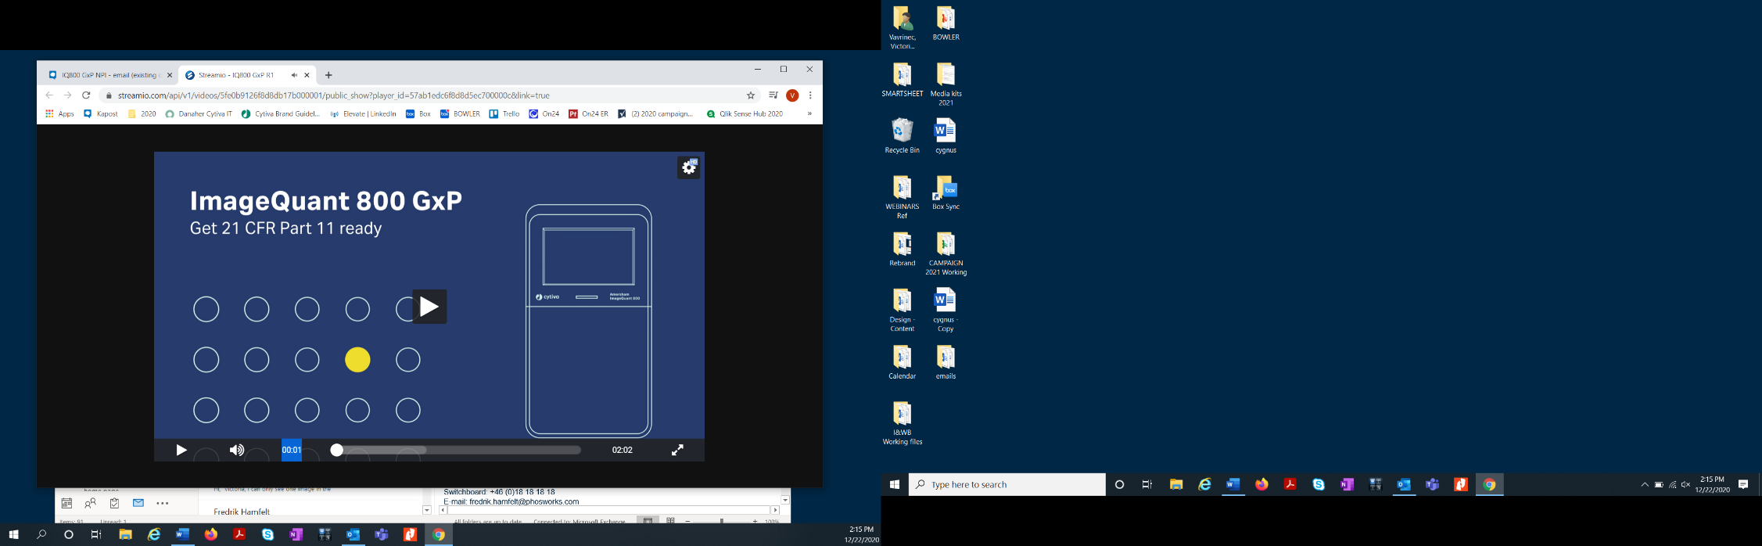

See how we can support your imaging workflow compliance.  
Link for video: https://share.vidyard.com/watch/vLuMvwXwgWv9pwYwd2HB8n

Learn more

Watch video

Sincerely,

Link to learn more <https://www.cytivalifesciences.com/shop/protein-analysis/molecular-imaging-for-proteins/imaging-systems/amersham-imagequant-800-systems-p-11546?extcmp=cy21009-gl-gcr-gen-iq800gxpnpi-em-exv-biopharm-npi>

The Imaging and Western Blotting Team at Cytiva  
[cytiva.com/IQ800GxP](https://www.cytivalifesciences.com/shop/protein-analysis/molecular-imaging-for-proteins/imaging-systems/amersham-imagequant-800-systems-p-11546)

|  |
| --- |
|  |
| Cytiva and the Drop logo are trademarks of Global Life Sciences IP Holdco LLC or an affiliate.  ImageQuant is a trademark of Global Life Sciences Solutions USA LLC or an affiliate doing business as Cytiva. © 2021 Cytiva  [Unsubscribe](https://www.cytivalifesciences.com/unsubscribe) | [Communication preferences](https://www.cytivalifesciences.com/preferences) | [Contact](https://www.cytivalifesciences.com/support/contact-us) |