Subject Line: Draco Full Spectrum Mushroom Extracts: Health Support Powerhouses

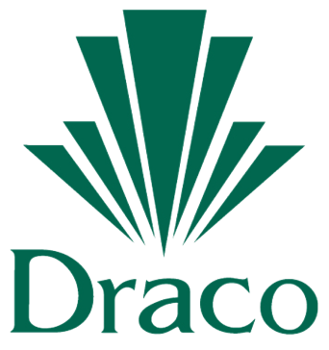

The Best of Science, Nature, and Tradition

[INSERT PHOTO]

Medicinal mushrooms continue to grow in popularity as more and more people in the health and wellness space discover their powerful benefits. They are valuable for their medicinal effects, due to the presence of complex large chain polysaccharides like beta glucans. These polysaccharides can be easily damaged during extraction with chemical solvents or heat. **Draco mushroom extracts** are Full Spectrumextracted in pure water with no solvents or high temperatures, resulting in a balanced, efficacious extract powder.

**Draco mushroom extracts** are nutrient dense carrier free whole food extract ingredients that are clean, safe and natural. We start with the whole mushroom, sustainably grown and harvested. No growing media like grain substrates found in cheaper mycelium versions are used. We can also produce specialty extracts with enhanced bioactives using probiotic fermentation, or with high oil content using supercritical CO2 extraction, upon request.

Some popular mushrooms currently offered:

**Reishi mushroom** *(Ganoderma lucidum)* is a medicinal mushroom that has symbolized great health and longevity throughout thousands of years of Chinese history. It supports a calm state of mind, increased energy, and normal cell function. Scientific studies show that it helps promote a healthy immune response, normal liver function, and a healthy seasonal histamine response.

**Lion’s Mane mushroom** (*Hericium erinacines*) is reported to be a good source of B vitamins, selenium, and copper. The mushroom contains polysaccharides, hericenone, erinicines, and sterols. It helps support normal cholesterol and lipid levels, cognitive health and mood, and immune health.

Draco has a full line of pure water extracted Full Spectrum medicinal mushrooms for your product lines, including Chaga, Shiitake, Chantrelle, Maitake, Oyster Mushroom, Cordyceps, Grifola umbellata, Agaricus ABM, Poria Cocos, Turkey Tail mushroom, Tremella, Enokitake, King Bolete (Porcini), Morel, Polypore, and others offered as well.

Click here to learn more about Draco’s offerings and the benefits from these mushrooms.