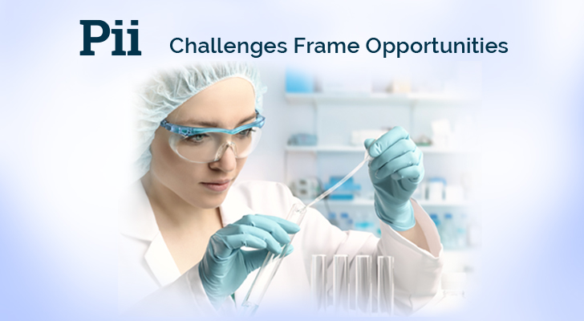

**Email #3:**

**Subject Line: Pii Capabilities Presentation and article on Phase-Appropriate Drug Development – Validation Process**

<<First Name>>,

Pii's history includes experience in developing its own drug therapies as well as helping other drug developers advance their own products. Through this experience, we have gained insight and empathy for what it takes to take drug therapy from concept to clinical to commercialization. [You can learn more about us here.](https://www.pharm-int.com/about-us/)

Additionally, I thought you might be interested in how we approach the drug development process. According to Dr. Tomas Ingallinera, our VP of Technical Services, a *"Phase appropriate method to drug process development... understanding of "what" is needed and "when" it's needed for each phase of the drug."* You can read his entire article here: [phase-appropriate development process](https://www.pharm-int.com/2020/08/27/phase-appropriate-drug-development-validation-process/).

If you are working on a project, and want to learn more about our capabilities, feel free to [book a meeting with us here](https://t.sidekickopen78.com/s1t/c/5/f18dQhb0S7lM8dDMPbW2n0x6l2B9nMJN7t5XWPfhMynW7gr-dK5wvLJnN56dFP4Vfl3T102?te=W3R5hFj26QkGZW45SVDg4hCWyFW43X00w43T4P1W3K3q0941S8nhF45N08sWsMB1&si=8000000003745937&pi=bdf8105f4e849da559433cb6c6cad135).

Signature

**=====================================================================================**