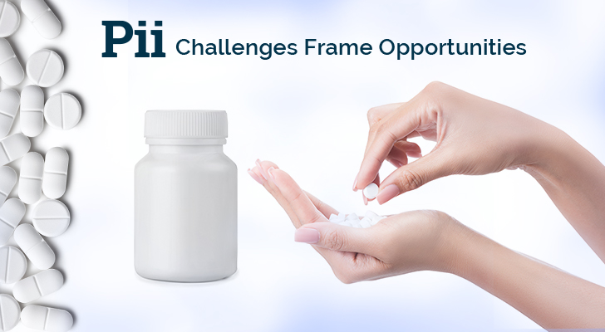

**Email #4: Pii - Concept – Clinic – Commercialization**

**Subject Line: Pii - Concept to Clinic – A collaborative approach.**

 <<First Name>>,

Thank you again for your interest in Pii's content! When it comes to helpful content, we know you have far more options than time available; many thanks.

In response to an unprecedented number of innovative drug therapy candidates in early development, we applied our best operational thinking and invested in resources intended to streamline the drug development process from concept to clinic to commercialization. We are proud of the results we are achieving for our clients.  Learn more. (link this to the CCC hub page – available next week)

If you are working on a development project and want to learn more about our capabilities, feel free to [book a meeting with us here](https://t.sidekickopen78.com/s1t/c/5/f18dQhb0S7lM8dDMPbW2n0x6l2B9nMJN7t5XWPfhMynW7gr-dK5wvLJnN56dFP4Vfl3T102?te=W3R5hFj26QkGZW45SVDg4hCWyFW43X00w43T4P1W3K3q0941S8nhF45N08sWsMB1&si=8000000003745937&pi=bdf8105f4e849da559433cb6c6cad135).

Signature

 ====================================================================================