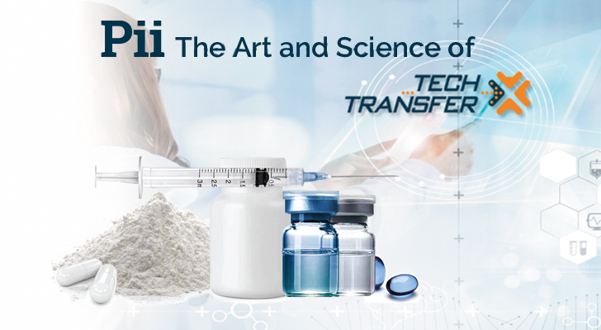

**Email #5: Pii -  Tech Transfer – Commercialization**

**Subject Line: Pii – Tech Transfer – Experience counts**

<<First Name>>

A Pharma Tech transfer is often viewed as a complex process fraught with risk and the potential for something to go wrong. We believe that tech transfer done expertly is an opportunity to deliver better results to our clients and, ultimately, patients.

Whether you have an early concept project or looking to scale your drug product's manufacturing, we approach each project seeking improvement: increased efficiency, lower costs, improved processes, better validation procedures, and more robust quality systems.

Learn more. <https://www.pharm-int.com/tech-transfer/>

If you are working on a more extensive Phase III that requires a transfer from the development CRO or a commercial tech transfer project and want to learn more about our capabilities, feel free to [book a meeting with us here](https://t.sidekickopen78.com/s1t/c/5/f18dQhb0S7lM8dDMPbW2n0x6l2B9nMJN7t5XWPfhMynW7gr-dK5wvLJnN56dFP4Vfl3T102?te=W3R5hFj26QkGZW45SVDg4hCWyFW43X00w43T4P1W3K3q0941S8nhF45N08sWsMB1&si=8000000003745937&pi=bdf8105f4e849da559433cb6c6cad135).

Signature

 ====================================================================================