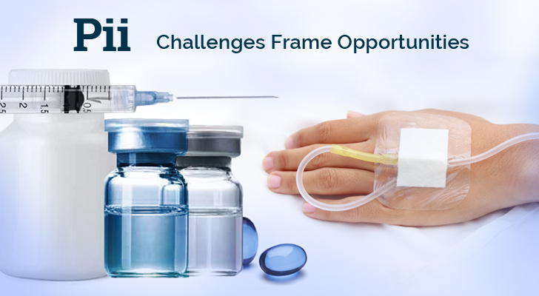

**Email #1: Intro to Pii with a tie into Oncology and VC**

**Subject Line: Pii - CDMO - Parenteral - Solid Dosage (Cytotoxic/Highly Potent/Hormone) Capabilities**

<<First name>>,

Oncology innovations remain a top beneficiary of VC investments, and according to [this VMG health article](https://t.sidekickopen78.com/s1t/c/5/f18dQhb0S7lM8dDMPbW2n0x6l2B9nMJN7t5XWPfhMynW7gr-dK5wvLJnN56dFP4Vfl3T102?te=W3R5hFj4cm2zwW4kH0cK3K1LpYW3Qz6XD3_rgRnW43QBYh41Qv7YW43QKpV43Tw4jW3Q-Yhj3T3pkwW45TQMv3zhrNGW3K8pPt4fQQQZW41ZnhD4fKX1-W4fdh0F1GyZbzW3F6jQc3F4FXL1V3&si=8000000003745937&pi=bdf8105f4e849da559433cb6c6cad135) it doesn't look to slow down over the next two years, in spite of the attention being given to COVID vaccine development.  The ability to advance promising cancer drug therapies will continue to be important to our industry, and we've taken strategic steps in developing capabilities to keep pace with the need:

* **Small batch, Phase I and Phase II, aseptic fill and finish**
* **Managing risk with cytotoxic and highly potent API**
* **Optimizing filling technology to minimize API loss**

I hope you're finding our Linkedin content valuable, it appears to be popular among the consultant community, and Pii's relationships with consultants is important to us.

Pii, or Pharmaceutics International Inc., is a US-based contract development and manufacturing organization. Our scientists and engineers frequently share knowledge and best practices with the industry, and we welcome you to access it and offer your comments. [Here is a link to our website](https://www.pharm-int.com/).

If you have a project you are working on and would like to discuss it with one of our top scientists, please [book a meeting with us here](https://t.sidekickopen78.com/s1t/c/5/f18dQhb0S7lM8dDMPbW2n0x6l2B9nMJN7t5XWPfhMynW7gr-dK5wvLJnN56dFP4Vfl3T102?te=W3R5hFj4cm2zwW3_SMKM3T1k87W1JzCRv4cNDSbW1JxwY51LCsFtf45SzNg04&si=8000000003745937&pi=bdf8105f4e849da559433cb6c6cad135).

**Paul Dupont**

**Head of Digital Marketing**

**Cell: 1-443-800-1866**

**Email:**[**pdupont@pharm-int.com**](mailto:pdupont@pharm-int.com)