**USP Verification**

**PharmTech Promoted Email Strategy**

**CAST Deployment Emails:** Three emails with 6,500 names per email; 19,500 names total receive an email.

Given this tactic is not a “progressive” approach, JPA recommends all three emails promote the Dedicated Dialogue (podcast and two-page Q&A with Danita on COVID-19’s impact on quality drug products and ingredients), but that we target a different audience segment for each email to better understand which audience values the messaging the most by measuring open rates and click-through rates. Note: This tactic ***does not*** provide lead contact information. In each email, we will also have the call-to-action to learn more at USP.org/verification.

***Email Content***

[Header image]

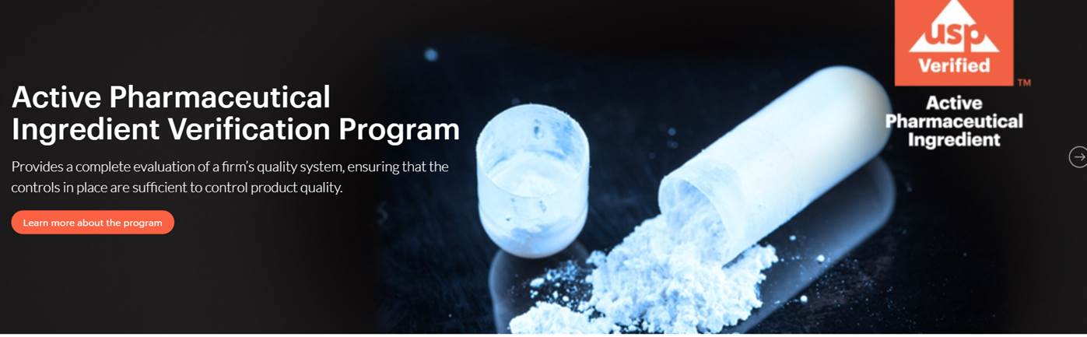

[Headline:] COVID-19's Impact: Help Ensure Quality and Manage Risk

[Copy:] The COVID-19 pandemic has disrupted the drug manufacturing industry unlike any the global supply chain has seen—from the FDA’s process for inspecting drug manufacturing facilities to ingredient and product shortages with subsequent surges. USP’s Danita Broyles discusses these challenges and USP’s solutions to help ensure quality and manage risks across the global supply chain.

Listen to the podcast: [Link to podcast]

Read the article: [Link to article]

[USP IVP Call-to-action section:]

* [Drug-product manufacturers:]

**Disruptions to your supply chain do not have to mean compromising quality.**

The USP Ingredient Verification Program helps you ensure the quality of APIs and excipients in addition to supporting the qualification of your suppliers.

Get started at [www.usp.org/ivp](http://www.usp.org/ivp).

* [Ingredient suppliers/contract manufacturers:]

**Differentiate your ingredients in an increasingly competitive global market.**

The USP Ingredient Verification Program helps you ensure the quality of APIs and excipients in addition to differentiating yourself as dedicated to quality.

Get started at [www.usp.org/ivp](http://www.usp.org/ivp).

[Footer image]



