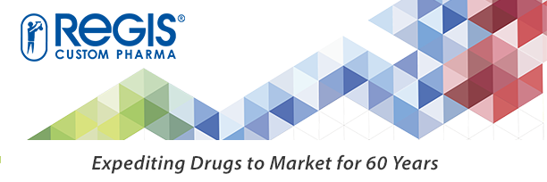

**Great Partnerships Begin with Great Chemistry and Regis Technologies, A Full Service CDMO**

Regis Custom Pharma is a premier cGMP full-service Contract Development Manufacturing Organization focused on the formulation and development of small-molecule active pharmaceutical ingredients (APIs). Our mission is to help Biotech and Pharmaceutical companies expedite new chemical entities to market. Our expertise lies in managing complex development programs while navigating IND and NDA requirements to effectively develop, scale-up, and deliver API manufacturing strategies from preclinical through commercialization. Regis has a history of successfully developing multiple novel APIs that have been approved in over 50 countries.

[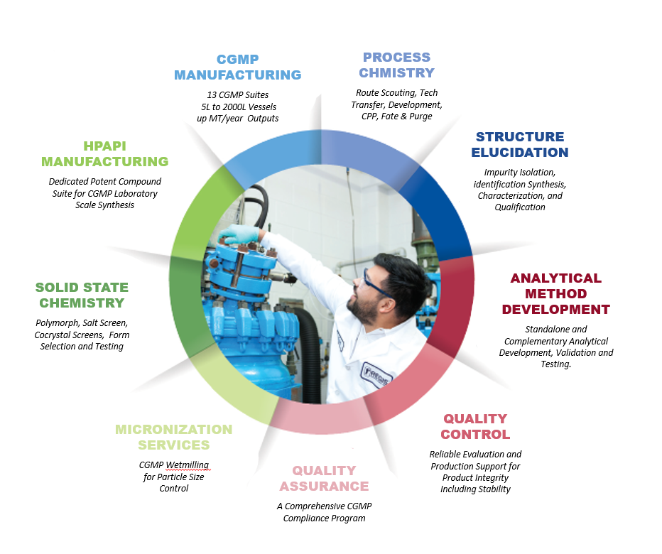](http://go.registech.com/customPT)

**Focused**   
Committed to advancing your API from development through commercialization

**Quality**   
A decade of clean

FDA Compliance

**Local**US-Based in the

Chicagoland area

**Trusted**

Family owned and

operated for 60 years



**Partner with Regis and let us help you expedite your small molecule API to market.**

**To get started or to learn more, visit** [**registech.com/custompharma**](http://www.registech.com/custompharma)

**The chemistry may be complex, but the reasons to partner with Regis are simple.**