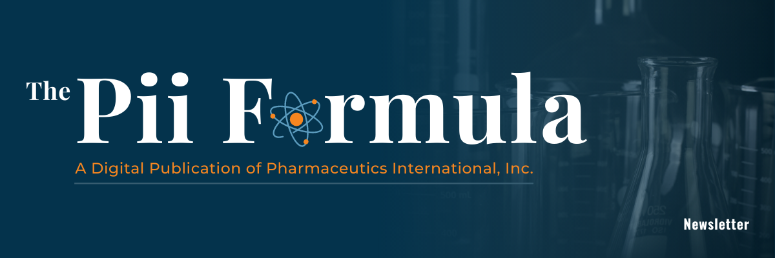
Email #6 Break-up – Intro to Pii Quarterly (or monthly TBD) Newsletter
Subject Line: The Beaker – Pii's New Quarterly Newsletter
<<First Name>>,
Many thanks for taking the time to explore some of Pii's content. Perhaps your priorities have changed, or maybe you simply haven't had time lately to read my emails.
I encourage you to take a look at Pii's monthly digital publication, The Pii Formula, and explore its content when you have the time. If you find it valuable, please subscribe and have it delivered to your email inbox quarterly and share it with your colleagues too. The Pii Formula: www.pharm-int.com/newsletter
Paul Dupont
Head of Digital Marketing
Cell: 1-443-800-1866
Email: pdupont@pharm-int.com

