Email Content:
Headline:
Streamlining the validation journey with Celsis® Complete & Celsis® Advantage Validation Support Packages
<Insert Attached Graphic>
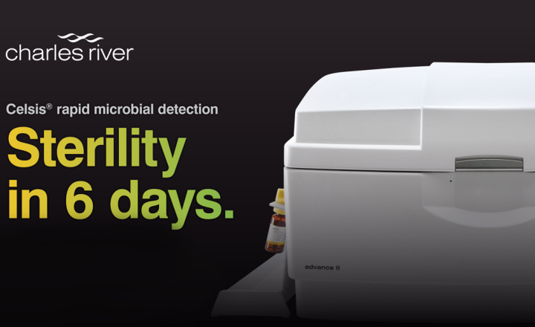
Body:
We are pleased to announce two support packages designed to easily demonstrate validation parameters described by United States Pharmacopoeia (USP) <1223>, European Pharmacopoeia (Ph. Eur.) 5.1.6, and Parenteral Drug Association Technical Report (PDA TR) 33, providing a complete solution that reduces the time from installation to routine use of your Celsis® rapid detection system.
These validation solutions allow quality control laboratories two choices to accelerate their validation strategy and reduce the time to full implementation by months. Depending on an organization’s resources, such as laboratory staff, bandwidth, and capabilities, labs seeking to implement their Celsis® platform can elect to either outsource the validation entirely, or purchase pre-written, easy-to-follow validation protocol templates.
With the Celsis® detection platform for rapid sterility, we’ve created an unprecedented set of solutions, features, and options in a package that’s designed for simplicity, not complexity. Instead of just providing an instrument with reagents and leaving the rest up to you, we’ve done the upfront work by partnering with other industry leaders to create a solution that makes perfect sense.
CTA: Jumpstart Your Validation (Tracked URL: https://www2.criver.com/l/60962/2021-03-26/hw82h2)

