

**Subject line: Valve technology for closed fluid delivery**

The home healthcare market is rapidly growing and is forecasted to continue to grow at a CAGR of 8-9% over the next five years. The delivery of fluids to and from the patient in applications such as infusion, drainage and dialysis are increasingly being done at home. The need to make these procedures safe and easy for the home care setting can be a challenge with respect to infection control and exposure to hazardous fluids (drugs and bodily fluids). The introduction of easy to use closed fluid delivery systems will help to reduce and eliminate some of these hazards.

In the hospital setting, the issues are similar with an emphasis on reducing infection rates, minimizing exposure to hazardous drugs and bodily fluids. There is also a workload component that can be addressed with making these fluid delivery systems more convenient and easier to use.

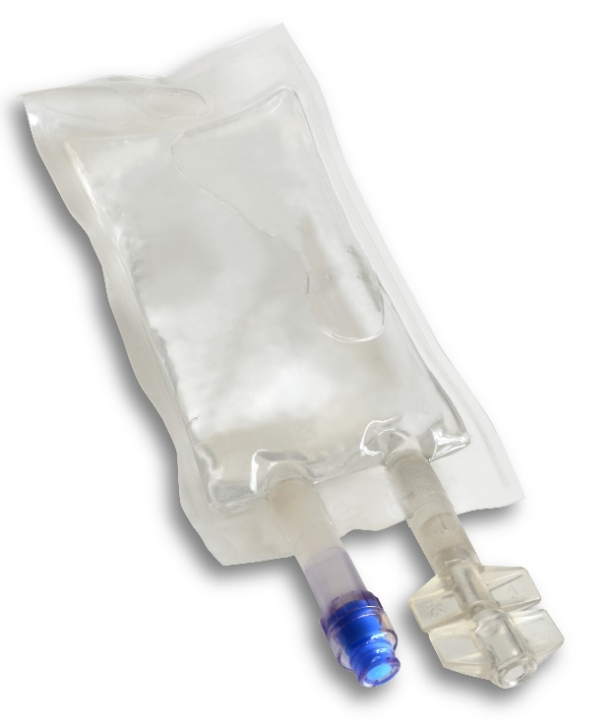The integration of a split septum luer activated valve system into the fluid delivery devices such as IV bags can help eliminate accidental spills and enhance ease-of-use for both the clinician and home care patient or caregiver.

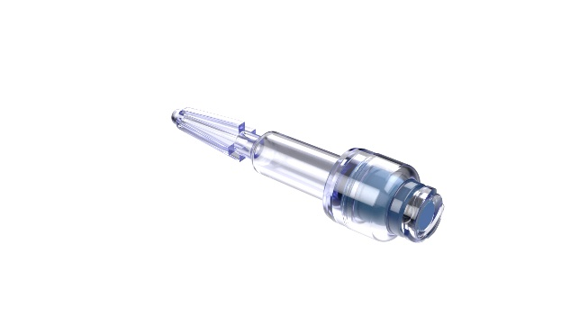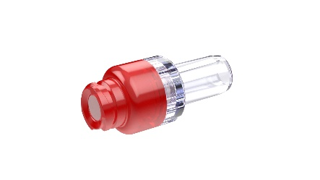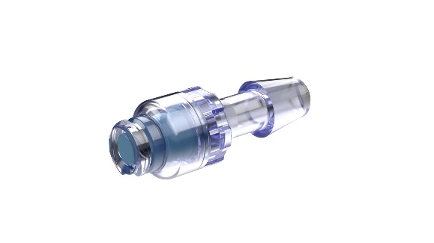

**Accidental Disconnections/Infection control**

Preventing fluid leakage has both safety and monetary consequences. Reducing exposure to biohazardous fluids and chemotherapeutic drugs is a huge safety concern but there is also a cost to these events such as clean up, exposure to patients/clinicians and regulatory reporting such as OSHA, etc. Another cost component is the expense of the drug/medication itself. Chemo drugs and antibiotics can cost several hundred to several thousand dollars per infusion. Having a leakage problem due to spiking issues or tubing set failure can lead to sterility issues that can cause infections. Having to discard several thousand dollars of drug can be a real issue that can be minimized by using a closed valve delivery system. Accidental disconnections can happen as patients can be up walking around during the infusion or have to visit the rest room and accidently disconnect their infusion line from their catheter.

With the push for more medical care to be performed outside of the hospital, there is a need to simplify these procedures and make them easy to use for the caregivers and patients. The use of a closed fluid delivery system allows for ease of use and the enhancement of safety while helping to reduce the cost of these procedures.

Halkey Roberts has the most comprehensive line of split septum valves that can be integrated into fluid delivery systems such as IV bags and drug delivery system

Visit our website for more information and to request free evaluation samples

<https://www.halkeyroberts.com/needlefree-swabable-valves>