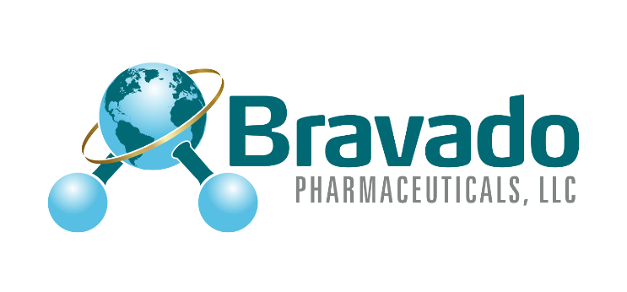

We are Bravado Pharmaceuticals. As a young and innovative team we will work with dedication and quick turn around to formulate, analyze and test your product. Our team has over 70 years combined experience in the pharmaceutical space with hundreds of dosage forms and creative solutions behind us.

We Offer PILOT SCALE AND CLINICAL MANUFACTURING
• Solid oral (tablet, capsule). Tablets in multiple platforms including multi-layer and micro. Capsules in both solid fill and multi-particulate. Micro-tablets in capsules
• Liquid oral (solution, suspension and emulsions)
• Topical (lotions, ointments, creams and gels)

Download our brochure (CTA)

Please go to our site page to contact us. https://bravapharm.com/request-proposal/

Also, to learn more about our capabilities go to https://bravapharm.com/capabilities/

For more information or to setup an initial call please email:
mberberich@bravapharm.com
Molly Berberich
Project Logistics and Administrative Coordinator
813-991-4100 Office
813-504-6015 Cell

