SL A: We have 4 live webinars in December! Which ones are you joining?
SL B: Did you sign up for these webinars yet?

(header image: Join us for these webinars!)

Sit. Stay. Heel—Compliance Alliance & Follow Through With the Revenue: Innovative Ways of Having BOTH*
Wednesday, December 2
8 pm EST ● 5 pm PST
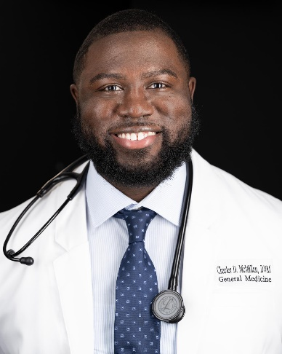  CHARLES MCMILLAN,  DVM | 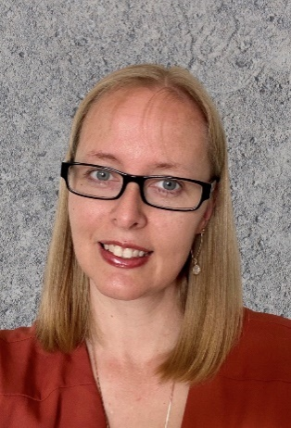  EMILY SHIVER,  CVPM, CCFP, CVBL | 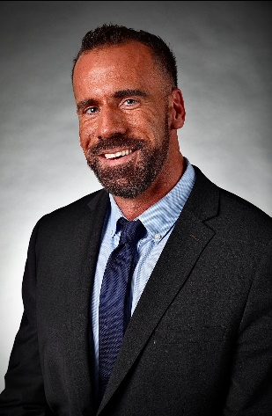  ADAM CHRISTMAN,  DVM, MBA, Chief Veterinary Officer at dvm360®

(REGISTER NOW button)
Sponsored by
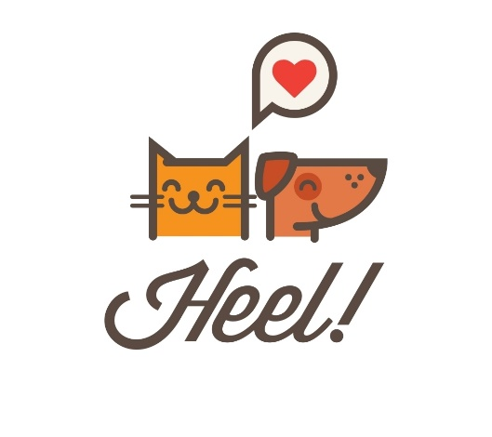

_________

Pet Insurance – Hype or Help?**
Tuesday, December 8
8 PM EST ● 5 PM PST
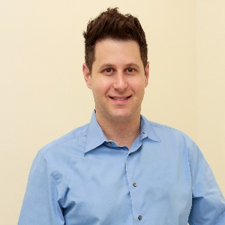  DAVID LISS,  RVT, VTS (ECC, SAIM), CVPM | 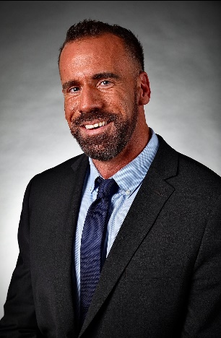  ADAM CHRISTMAN,  DVM, MBA, Chief Veterinary Officer at dvm360®
(REGISTER NOW button)
Sponsored by
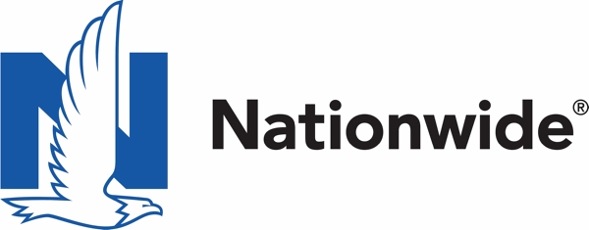
Nationwide, the Nationwide N and Eagle, and Nationwide is on your side are service marks of Nationwide Mutual Insurance Company. ©2020 Nationwide.
_________
Part 4 of 6: Integrative Oncology: Building Your Tool Kit**
Wednesday, December 9
8 pm EST ● 5 pm PST
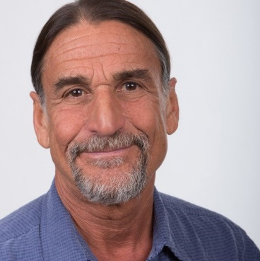  Robert J. Silver  DVM, MS | 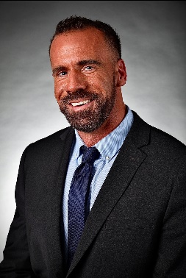  Adam Christman  DVM, MBA, Chief Veterinary Officer at dvm360®
(REGISTER NOW button)
Sponsored by

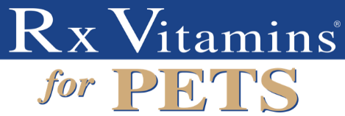

_________

*This program has been submitted (but is not yet approved) for 1 hour of continuing education credit in jurisdictions which recognize RACE approval.
**This program has been approved for 1 hour of continuing education credit in jurisdictions that recognize RACE approval.

