Improve your Chemical Analyses with Online FTIR Courses

Dear Colleague:

Improve your chemical analyses and boost your career with this acclaimed series of online FTIR courses taught by acknowledged infrared spectroscopy expert Dr. Brian C. Smith. Discover how to improve your scans, prepare samples properly, and interpret spectra successfully.
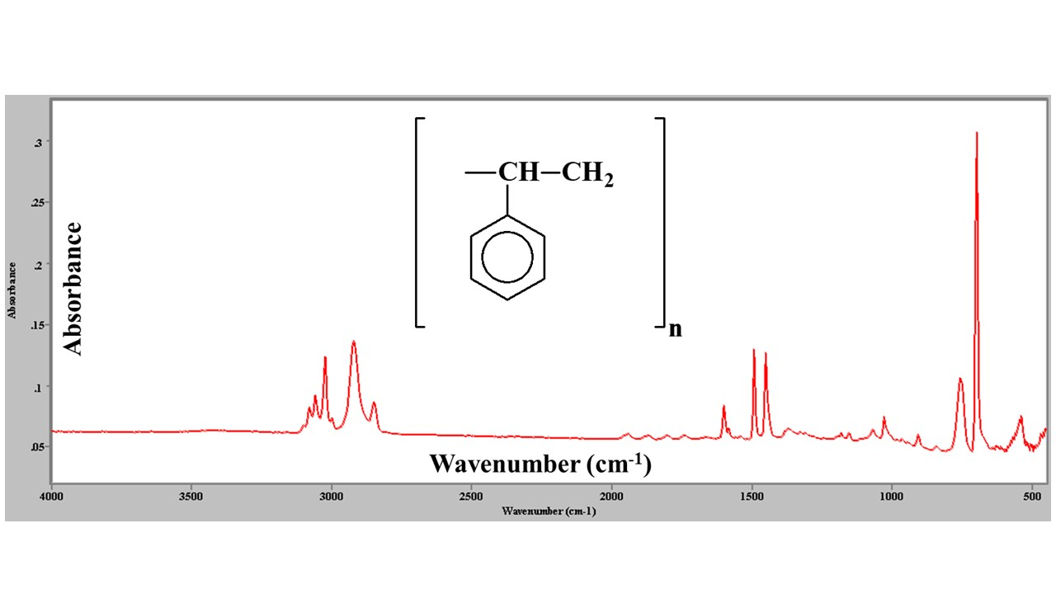

Learn More button links to: Big Sur Scientific Infrared Spectroscopy Training Courses – Big Sur Scientific

Your Instructor: Dr. Brian C. Smith (link to : Your Instructor: Dr. Brian C. Smith – Big Sur Scientific)
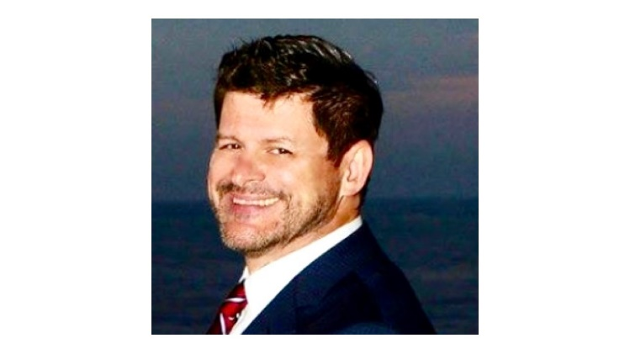
Since 1992 Dr. Smith has taught thousands of scientists around the world how to improve their chemical analyses. He teaches for the American Chemical Society and is a member of the faculty of the California Criminalistics Institute. Dr. Smith publishes a regular column in Spectroscopy magazine called Infrared Spectral Interpretation Workshop. He has written 3 books on infrared spectroscopy and earned his Ph.D. in physical chemistry from Dartmouth College.

Learn More button links to: Big Sur Scientific Infrared Spectroscopy Training Courses – Big Sur Scientific

