Subject line: Enabling Spectroscopy Solutions by Avantes

Header:



1.

Headline: All About Spectroscopy  
Message: Almost all products, objects and beverages that you use and consume every day, have encountered spectroscopy before it reaches your hands. Spectroscopy allows us to discover and research all kinds of materials with the help of light. From blood analysis to fruit sorting and from contamination monitoring to wafer inspection. More about spectroscopy (hyperlink)  
Hyperlink: <https://www.avantes.com/support/theoretical-background/>   
Image: see attachment, named Image 1

2.

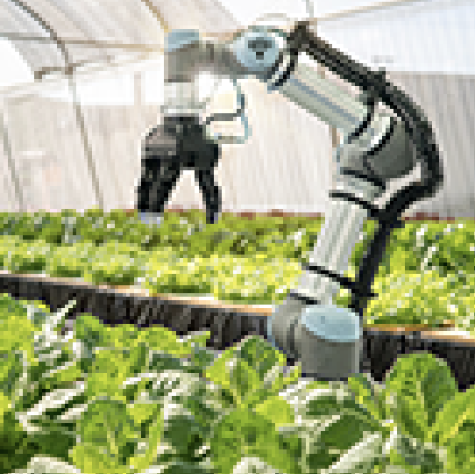Headline: Markets in which Avantes operates   
Message: Spectroscopy is utilized in numerous markets and industries all over the world. It can be applied in the lab, in-line at a production facility or in the field. By providing valuable measurement insights, your results can be improved. Curious how spectroscopy can help your research or business? Learn more (hyperlink)  
hyperlink: <https://www.avantes.com/applications/markets/>

Image: see attachment, named Image 2  
  
3.

Headline: Measurement Techniques Avantes Supports  
Message: Spectroscopy allows us to research materials in many ways due to the variety of measurement techniques that are available. Avantes supports numerous of techniques with their products. Learn more (hyperlink)  
Hyperlink: <https://www.avantes.com/applications/measurement-techniques/>

Image: see attachment, named Image 3  
  
4.

Headline: Enabling Spectroscopy Solutions  
Message: With nearly 30 years of experience in all kinds of industries, we’re an equipped partner to guide you in finding your most ideal setup or product integration. From spectrometers, fiber optics, light sources to software and accessories, we offer everything you need to start your measurement. Learn more (hyperlink).  
Hyperlink: <https://www.avantes.com/products/>   
Image: see attachment, named Image 4

5.

Headline: Free eBooks – Spectroscopy In Different Markets  
Message: You can encounter Avantes’ products in the agricultural sector, the medical field, solar industry, semiconductor market and many more. In every market, we contribute to science and enable our partners to make huge strides in quality, efficiency, and research. Curious how we do this? Download our free eBooks (hyperlink)

Hyperlink: <https://www.avantes.com/support/free-ebooks-spectroscopy-market-applications/>   
Image: see attachment, named Image 5  
  
6.

Headline: Application Notes  
Message: Outside our industry specific eBooks, we offer lots of application notes in which we dive deeper in specific applications in which our spectrometers are applied. Discover the divers application examples and learn more about customer challenges that Avantes has solved, together with its partners. Read application notes (hyperlink)  
Hyperlink: <https://www.avantes.com/applications/cases/>   
Image: see attachment, named Image 6

7.

Headline: Find Your Ideal Setup

Message: Avantes offers free feasibility studies, advice, and guidance. Visit our experience center for a hands-on demonstration, send over your material for a feasibility study or try our demo equipment. We make sure you find the most suitable solution for your application. Discover the options (hyperlink)  
Hyperlink: <https://www.avantes.com/about-us/experience-center/>   
Image: see attachment, named Image 7