**Email Subject:** Advances in the Analysis of New and Used Lubricating Oils

**Headline:** Advances in the Analysis of New and Used Lubricating Oils by High-Resolution ICP-OES

Link image here: <https://www.analytik-jena.us/knowledge/whitepapers/advances-in-the-analysis-of-new-and-used-lubricating-oils-by-high-resolution-icp-oes/>



**Copy:** Say goodbye to the challenges of lubricating oil analysis using [ICP-OES](https://www.analytik-jena.us/products/elemental-analysis/icp-oes/plasmaquant-9100/technology-highlights-icp-oes/). The PQ9100 from [Analytik Jena](https://www.analytik-jena.us/) offers a unique vertical torch design that eliminates soot formation while the dual view PLUS eliminates tedious sample preparation.  [Unrivaled plasma stability coupled with the highest resolution](https://www.analytik-jena.us/products/elemental-analysis/icp-oes/plasmaquant-9100/technology-highlights-icp-oes/) on the market makes the PQ9100 a laboratory staple.

**Button:** [Learn More](https://www.analytik-jena.us/knowledge/whitepapers/advances-in-the-analysis-of-new-and-used-lubricating-oils-by-high-resolution-icp-oes/)

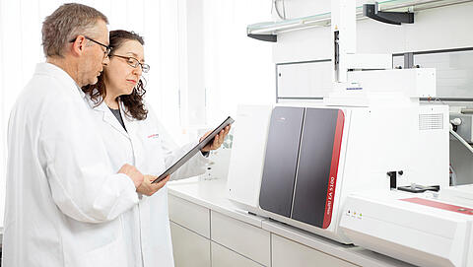**Sub Headline:  [Web Seminar: Creating Value in Downstream](https://www.analytik-jena.com/knowledge/e-learning/web-seminars/web-seminar-downstream/)**

In this web seminar our product specialists present solution strategies for complex application challenges in the downstream oil and gas industry. A special focus is on [**ICP-OES**](https://www.analytik-jena.com/products/elemental-analysis/icp-oes/plasmaquant-9100/)**>** techniques for the analysis of elemental impurities n fuels like diesel, gasoline or naphtha as well as the routine determination of carbon, nitrogen, sulfur and chlorine in these fuels via elemental analysis.

* Determination of elemental impurities in naphtha, gasoline and diesel utilizing high resolution ICP-OES
* Elemental analysis of carbon, nitrogen, sulfur and chlorine (C, N, S, X) in diesel, naphtha and gasoline
* C, N, S, X analysis of other liquids like hydraulic liquid via elemental analysis
* Insights into new ICP-OES and elemental analysis technology to simplify your workflow

Button: [Watch Now](https://www.analytik-jena.com/knowledge/e-learning/web-seminars/web-seminar-downstream/)

Sub headline 2: **Explore new technology from Analytik Jena**

### [compEAct](https://www.analytik-jena.com/products/elemental-analysis/cnscl-elemental-analysis/compeact/) Reliable analysis of sulfur and nitrogen - Simplify your quality control with compEAct

[PlasmaQuant PQ 9100 Series](https://www.analytik-jena.com/products/elemental-analysis/icp-oes/plasmaquant-9100/)

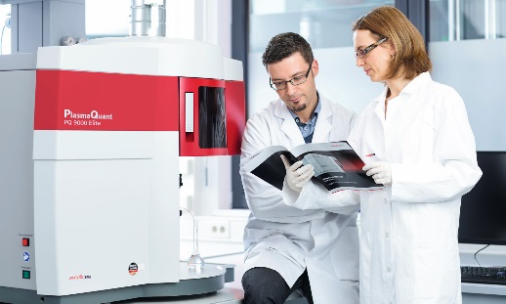More sensitive, robust, and reliable –  
 the ICP-OES for complex sample matrices

[Multi EA 5100](https://www.analytik-jena.com/products/elemental-analysis/cnscl-elemental-analysis/multi-ea-5100/)Your entire C/N/S/X lab in one device – A single analyzer for solid, liquid, gaseous and LPG samples

[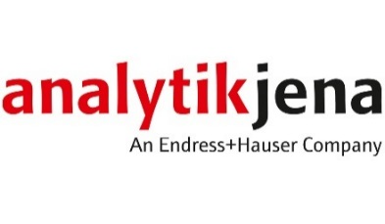](https://www.analytik-jena.us/)

[**www.analytik-jena.us**](https://www.analytik-jena.us/) **| 1-800-452-6788 |**[**info@us.analytik-jena.com**](mailto:info@us.analytik-jena.com)

[Facebook](https://www.facebook.com/AnalytikJena) | [LinkedIn](https://www.linkedin.com/company/analytik-jena-ag/) | [YouTube](https://www.youtube.com/user/AnalytikJenaAG) |[Instagram](https://www.instagram.com/analytikjena/)

**(include all active links)**